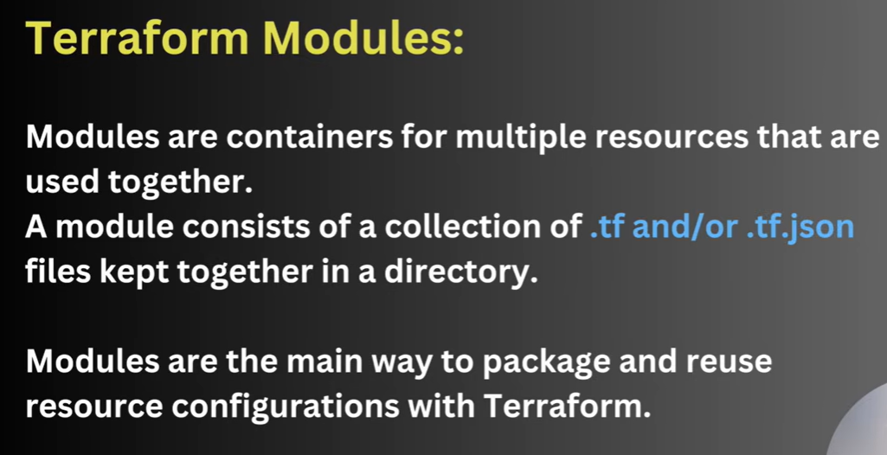

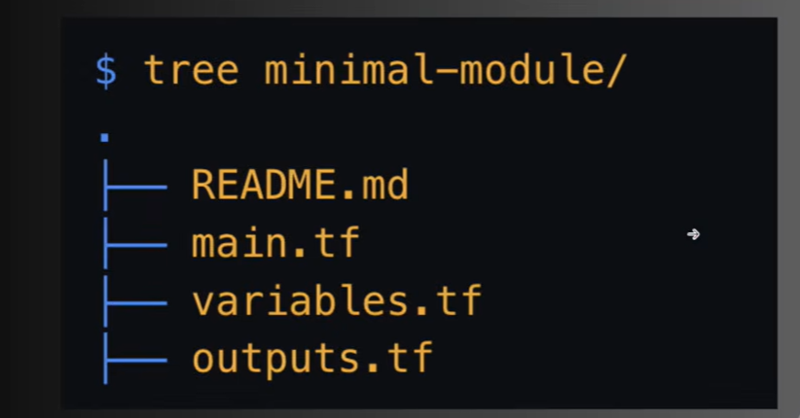

Aws has already created a lot of modules
https://registry.terraform.io/providers/hashicorp/aws/6.68.0
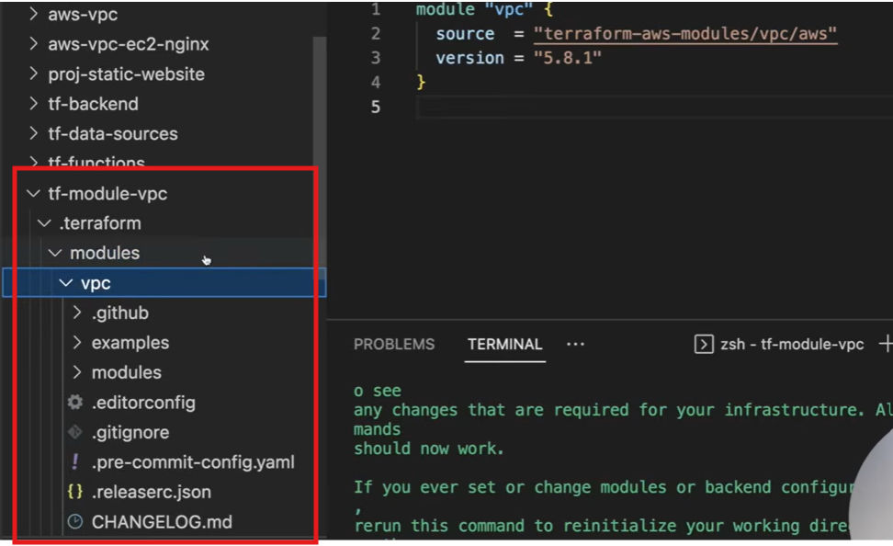
A lot of file will be automatically created including read me etc.

It`s not necessary to initialize the module to check the content but we can check on hit hub repo provided
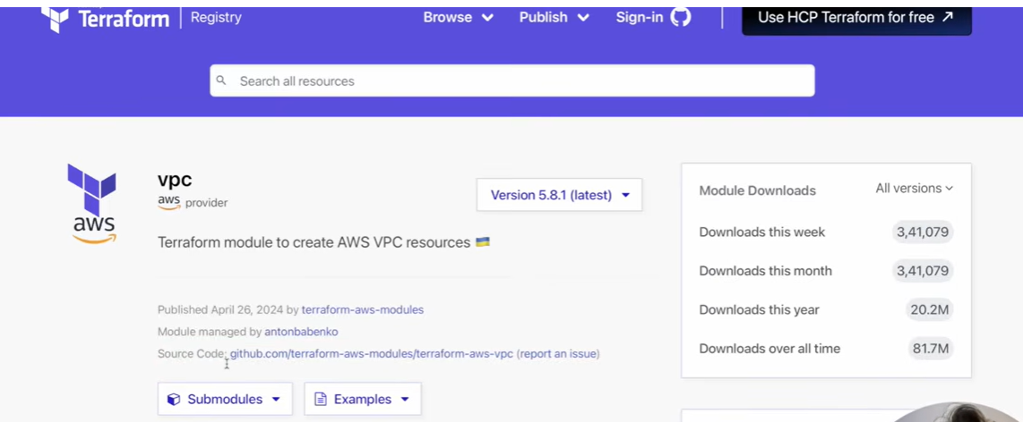
6:37:00
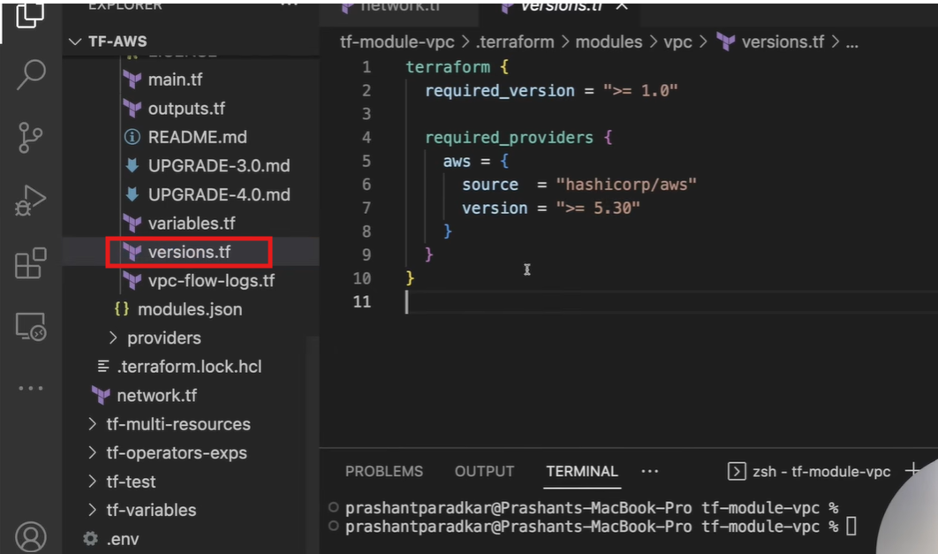
We have to take care of version if we are already working on some version.
We have all the set up in terraform providers
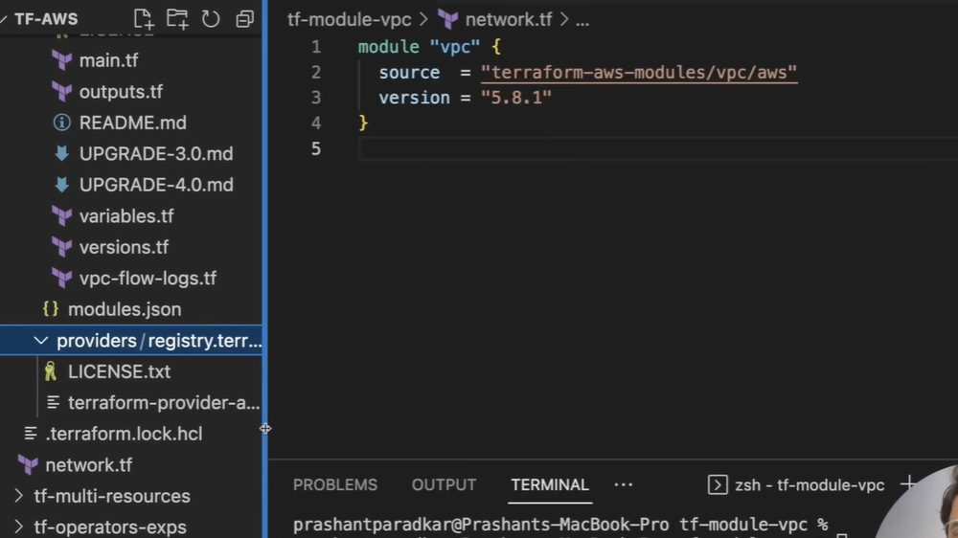
https://registry.terraform.io/modules/terraform-aws-modules/vpc/aws/latest
we refer to document.
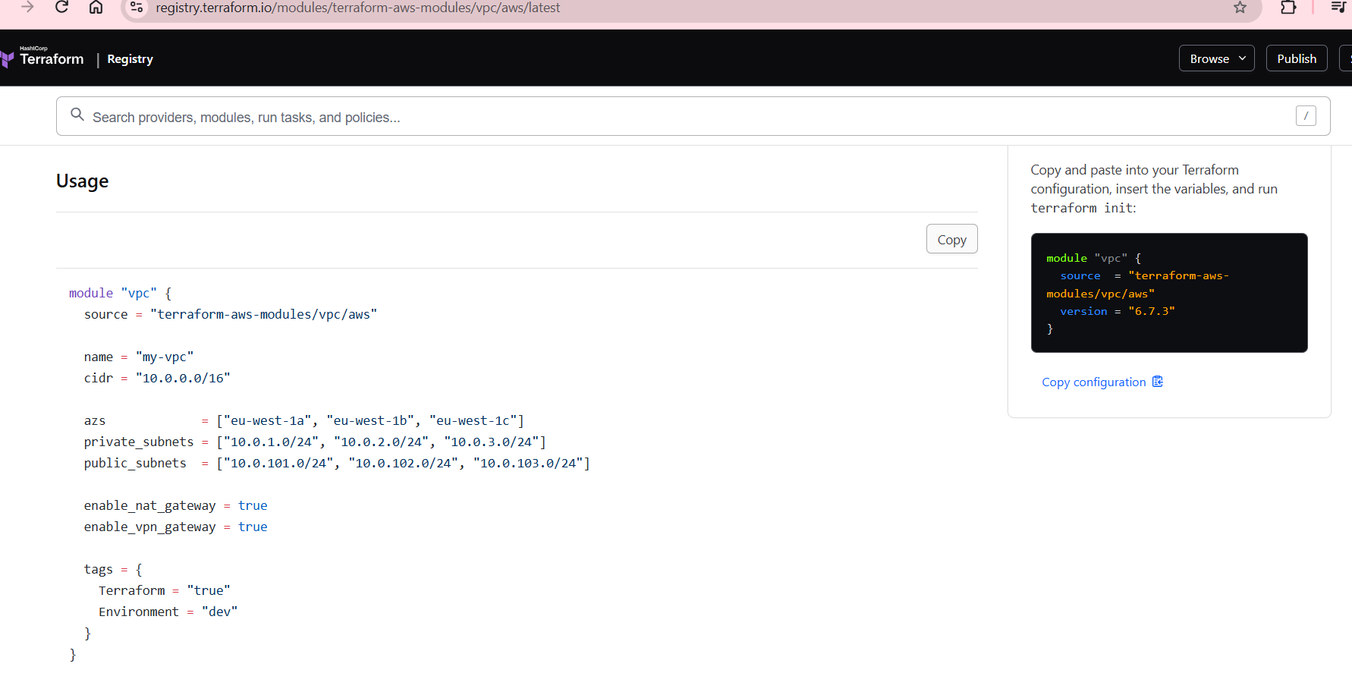

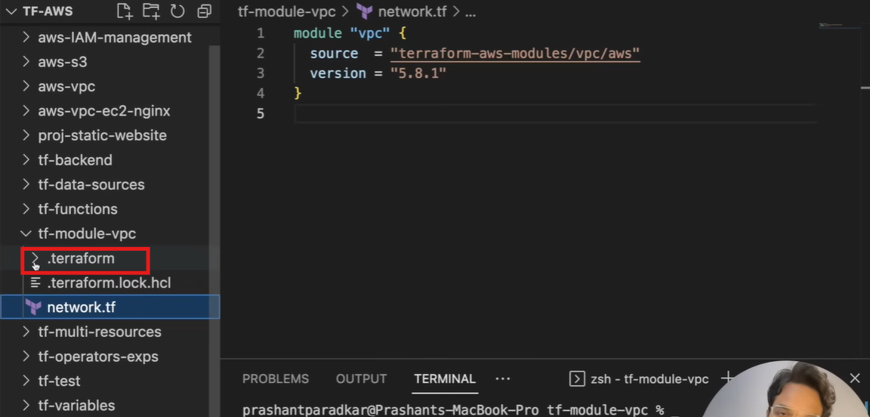
This is child module inside. terraform. if we need more control then we can create different file. We can create own file of provider like network.
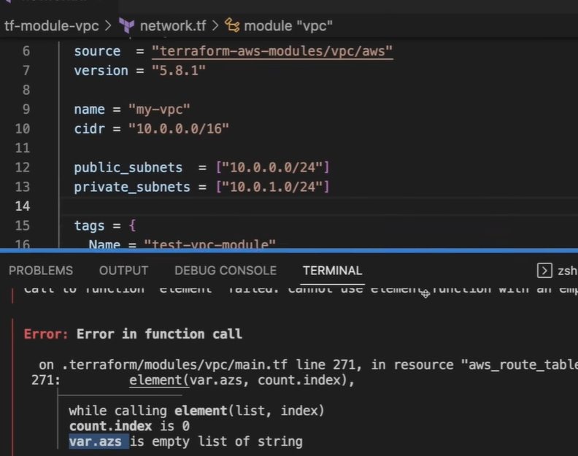
Availability zone is missing.
We can give static availability zone or we can use available one.
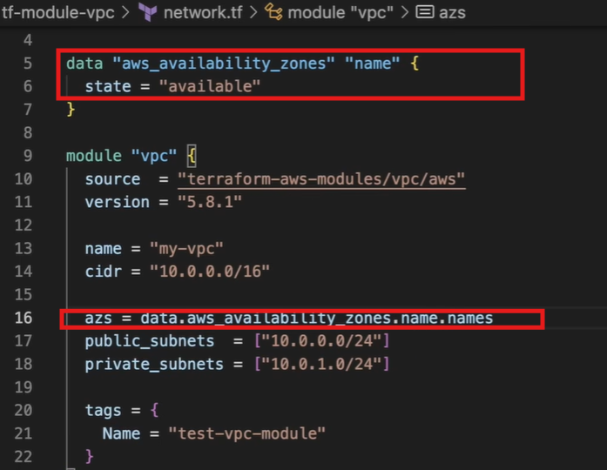
After using module readability inhanced
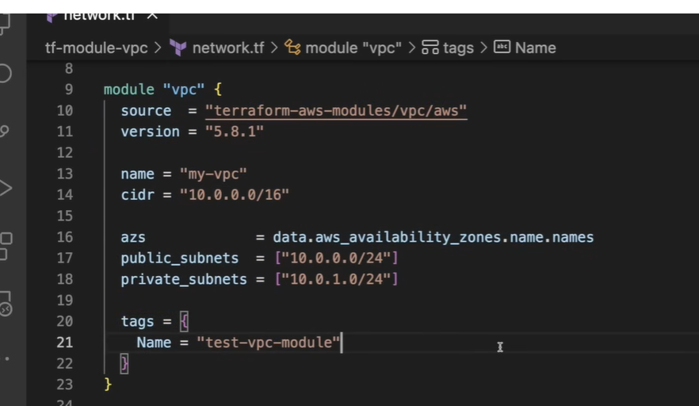
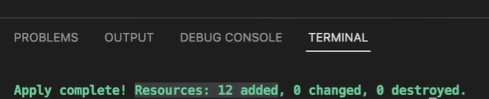
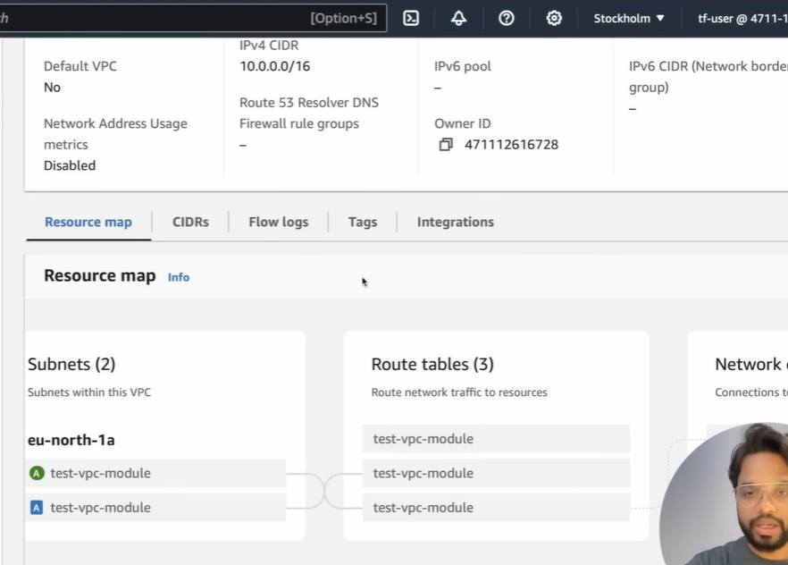
Desired things are created but we need some modification then we can do it.

We can use example file for reference.

We can use module for EC2
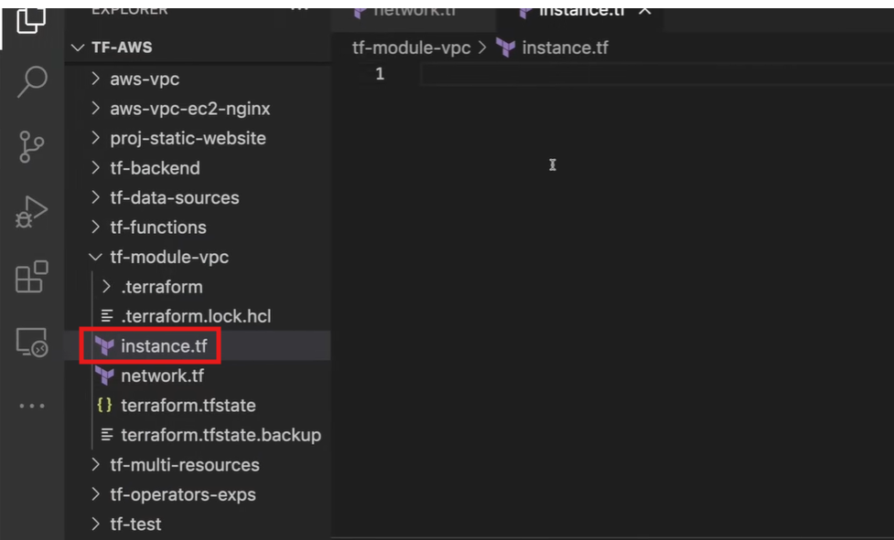
We can refer document for single and multiple instance
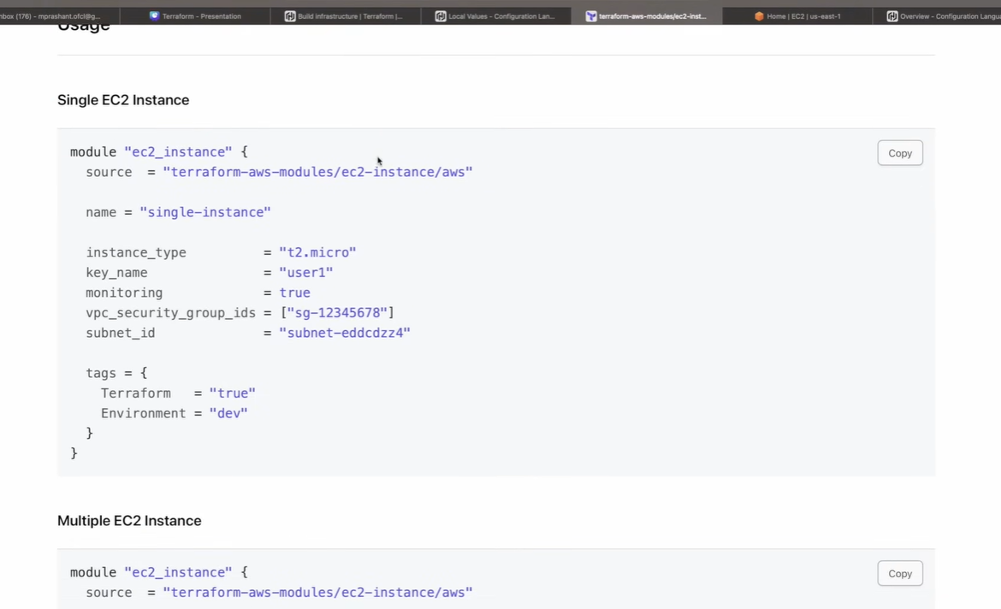

https://registry.terraform.io/browse/modules

To search security group go to vpc then output and now search
https://registry.terraform.io/modules/terraform-aws-modules/vpc/aws/latest?tab=outputs

